PAT 3
WEB TECHNOLOGIES LAB
SET 1
Name:Dimpul Sowjanya
REG NO: 23MIS1103

Question 1

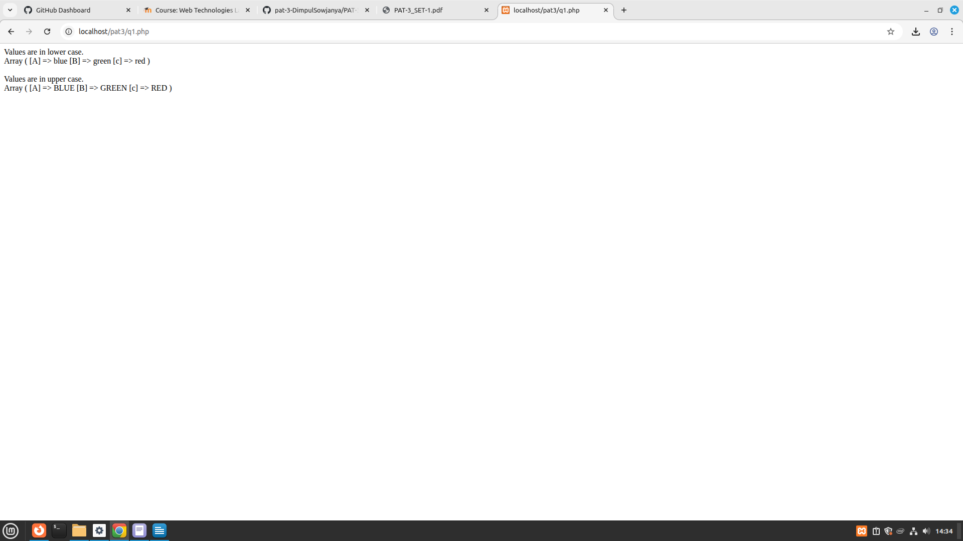
Question 2

Text File

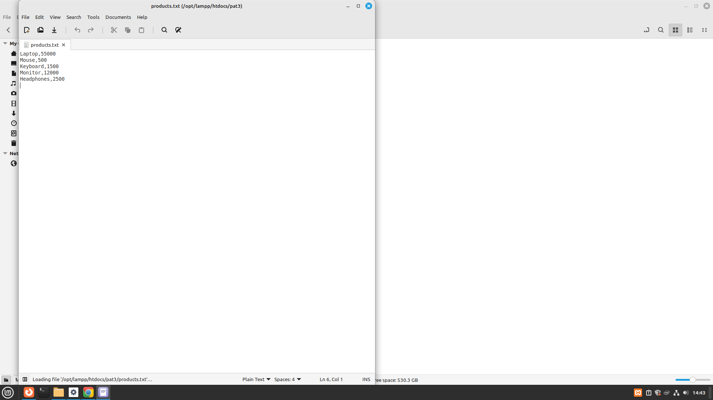

Output Screenshot

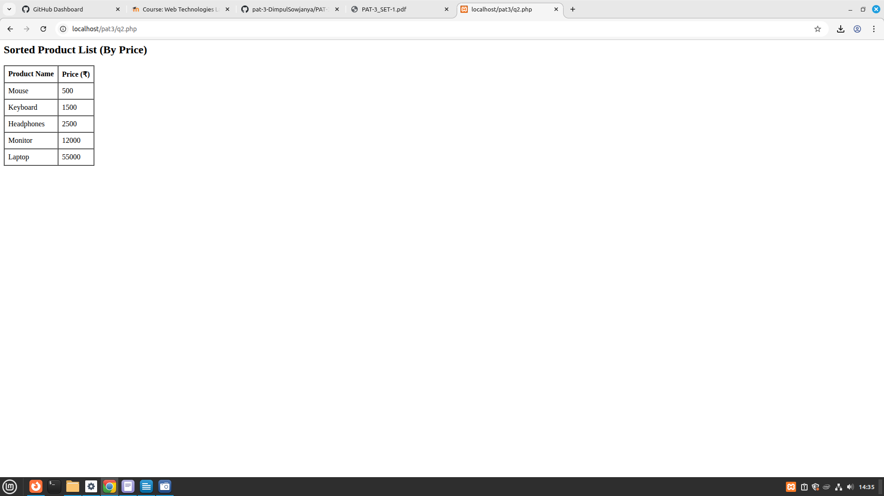

Question 3

screenshot when i opened for 3rd time

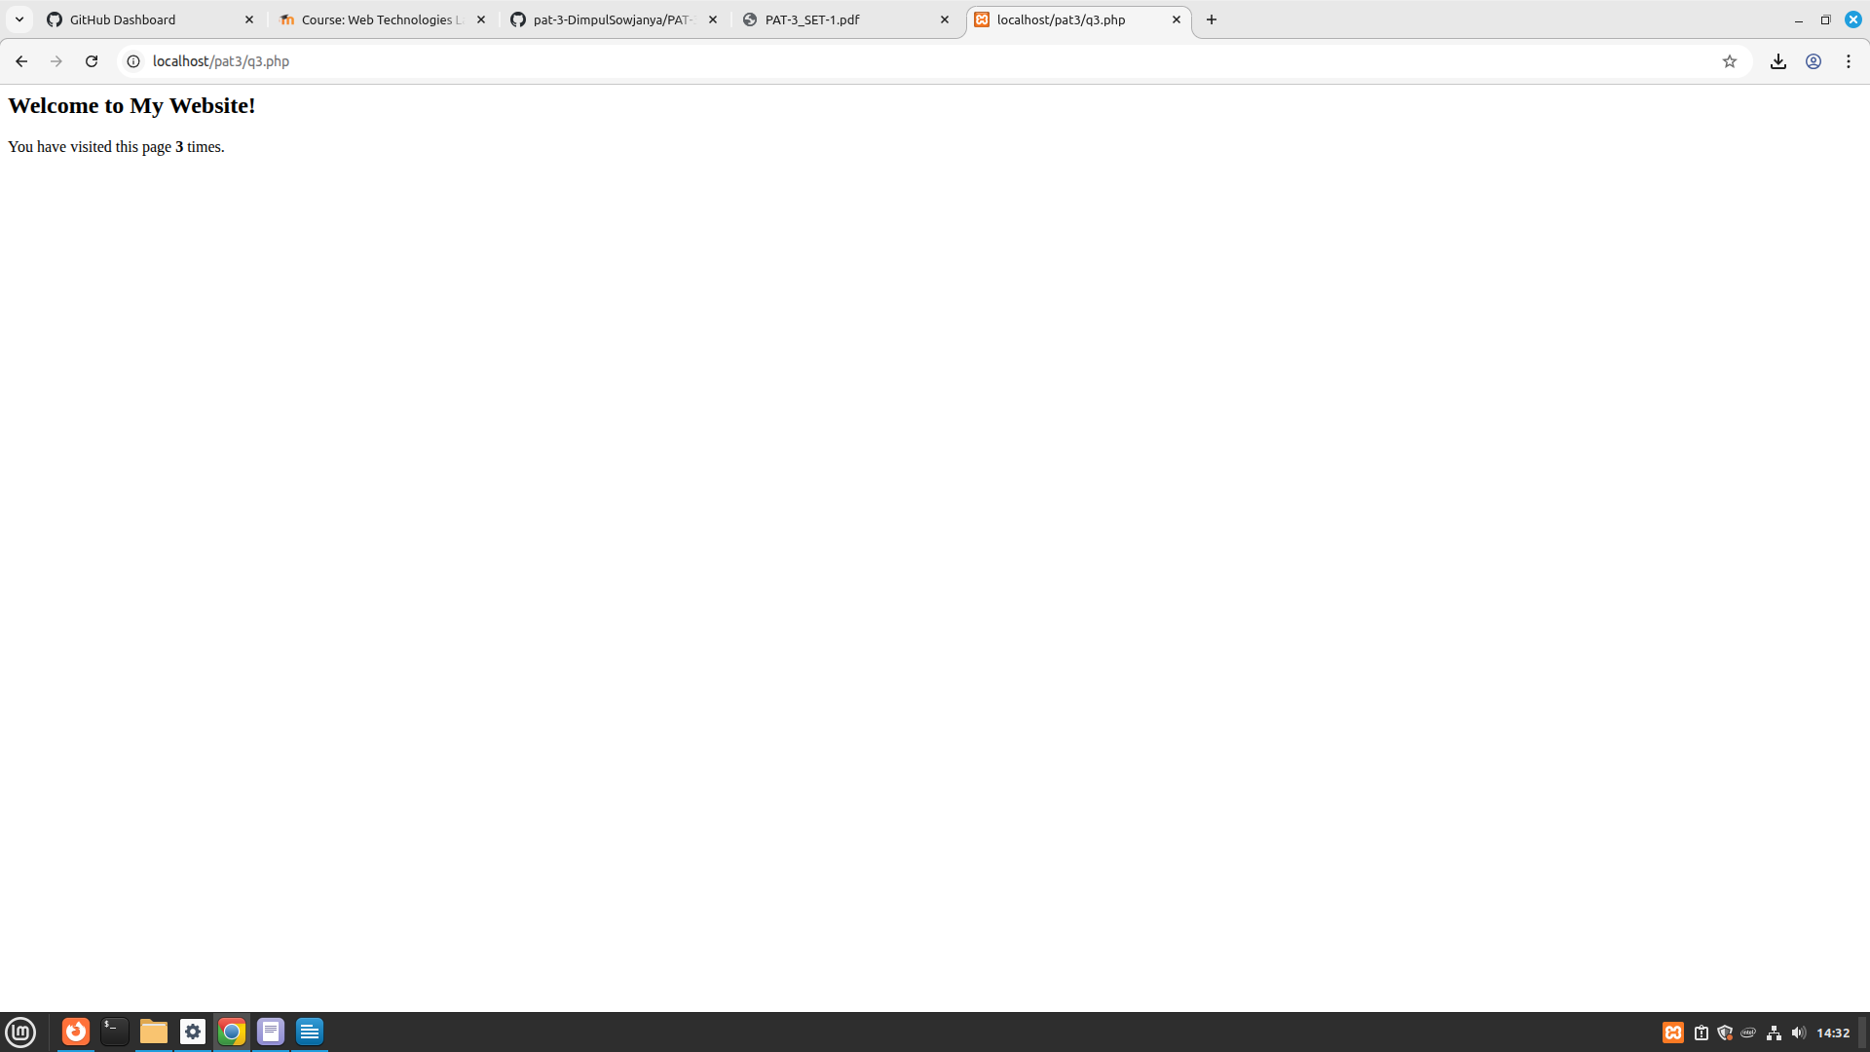

Screenshot when i opened for 4th time

